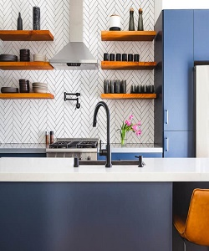

Profine Kitchen Cabinets

$275.57

Availability: In stock

Description

Modern kitchen cabinet design with white and grey counter tops light wood. And are available in a range of sheen levels, Full assembly instructions are included in the box, certified for the highest quality.